Ice Cream
Here’s the general protocol for the experiment:
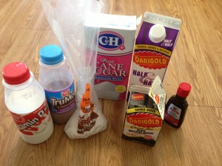
- Mix together 1/2 cup of half & half (or 1/4 cup of cream and 1/4 cup of milk), one tablespoon of sugar, and 1/4 tablespoon of vanilla and put in a quart-sized ziploc
- Fill a gallon ziploc 1/3 of the way with ice
- Add salt (rock salt or large granules, ideally)
- Place the ice cream ziploc inside the bag of ice and seal the bag
- Mix the ice/water around the inner bag for ten minutes
…and voilà!

